Contents

DIAGAMAS - RELACIONES 2

SQL QUERIES 11

# DIAGAMAS - RELACIONES

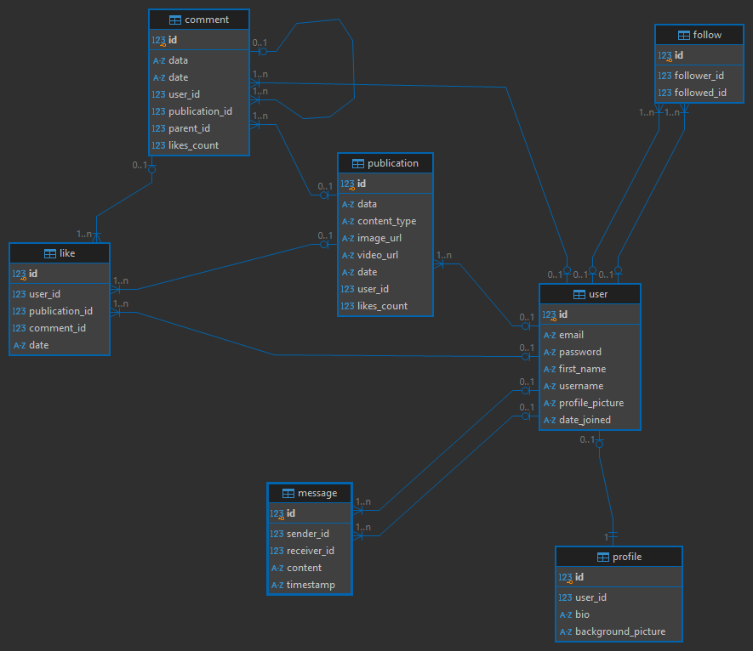

# SQL QUERIES

-- comment definition

**CREATE** **TABLE** comment (

id **INTEGER** **NOT** **NULL**,

data **VARCHAR**(1000),

date **DATETIME**,

user_id **INTEGER**,

publication_id **INTEGER**,

parent_id **INTEGER**,

likes_count **INTEGER**,

**PRIMARY** **KEY** (id),

**FOREIGN** **KEY**(user_id) **REFERENCES** user (id),

**FOREIGN** **KEY**(publication_id) **REFERENCES** publication (id),

**FOREIGN** **KEY**(parent_id) **REFERENCES** comment (id)

);

-- follow definition

**CREATE** **TABLE** follow (

id **INTEGER** **NOT** **NULL**,

follower_id **INTEGER**,

followed_id **INTEGER**,

**PRIMARY** **KEY** (id),

**FOREIGN** **KEY**(follower_id) **REFERENCES** user (id),

**FOREIGN** **KEY**(followed_id) **REFERENCES** user (id)

);

-- "like" definition

**CREATE** **TABLE** "like" (

id **INTEGER** **NOT** **NULL**,

user_id **INTEGER**,

publication_id **INTEGER**,

comment_id **INTEGER**,

date **DATETIME**,

**PRIMARY** **KEY** (id),

**FOREIGN** **KEY**(user_id) **REFERENCES** user (id),

**FOREIGN** **KEY**(publication_id) **REFERENCES** publication (id),

**FOREIGN** **KEY**(comment_id) **REFERENCES** comment (id)

);

-- message definition

**CREATE** **TABLE** message (

id **INTEGER** **NOT** **NULL**,

sender_id **INTEGER**,

receiver_id **INTEGER**,

content **TEXT**,

timestamp **DATETIME**,

**PRIMARY** **KEY** (id),

**FOREIGN** **KEY**(sender_id) **REFERENCES** user (id),

**FOREIGN** **KEY**(receiver_id) **REFERENCES** user (id)

);

-- profile definition

**CREATE** **TABLE** profile (

id **INTEGER** **NOT** **NULL**,

user_id **INTEGER**,

bio **TEXT**,

background_picture **VARCHAR**(200),

**PRIMARY** **KEY** (id),

**UNIQUE** (user_id),

**FOREIGN** **KEY**(user_id) **REFERENCES** user (id)

);

-- publication definition

**CREATE** **TABLE** publication (

id **INTEGER** **NOT** **NULL**,

data **VARCHAR**(10000),

content_type **VARCHAR**(50),

image_url **VARCHAR**(200),

video_url **VARCHAR**(200),

date **DATETIME**,

user_id **INTEGER**,

likes_count **INTEGER**,

**PRIMARY** **KEY** (id),

**FOREIGN** **KEY**(user_id) **REFERENCES** user (id)

);

-- "user" definition

**CREATE** **TABLE** user (

id **INTEGER** **NOT** **NULL**,

email **VARCHAR**(150),

password **VARCHAR**(150),

first_name **VARCHAR**(150),

username **VARCHAR**(150),

profile_picture **VARCHAR**(200),

date_joined **DATETIME**,

**PRIMARY** **KEY** (id),

**UNIQUE** (email),

**UNIQUE** (username)

);